# **Gender Pay Gap Reporting - 2021**

We are an employer required to carry out Gender Pay Reporting under the Equality Act 2010 (Gender Pay Gap Information) Regulations 2017.

This involves carrying out six calculations that show the difference between the average earnings of men and women in our organisation; it does not involve publishing individual employee data.

Gender Pay Reporting requires our organisation to make calculations based on employee gender. We have established this by using our existing HR and payroll records.

## Women's mean hourly rate is: 3.81% less

Mean pay per hour for men: £19.99

Mean pay per hour for women: £19.23 Difference in pay: £0.76

## Women's median hourly rate is: 6% less

Median pay per hour for men: £19.37

Median pay per hour for women: £18.20

Difference in pay: £1.17

|  |  |  |
| --- | --- | --- |
| **Quartiles** | **Men** | **Women** |
| Lower quartile | 29% | 71% |
| Lower middle quartile | 32% | 68% |
| Upper middle quartile | 32% | 68% |

Upper quartile 33% 67%

1,188 employees received bonuses during the relevant period – 98% were men and 92% were women. Women’s mean bonus pay was 0.61% lower than men’s, and there was no difference between women’s and men’s median bonus pay.

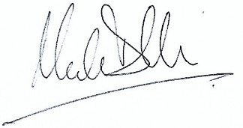

Mark Dollar Mary Fitzgerald

Chief Executive Officer Group HR Director

Dougie Dryburgh Mary Fitzgerald

Chief Executive Officer Group HR Director