South London Specialist Virology Centre

VIROLOGY

Laboratory User’s Handbook
October 2021 version



www.kch.nhs.uk www.viapath.co.uk www.synlab.com

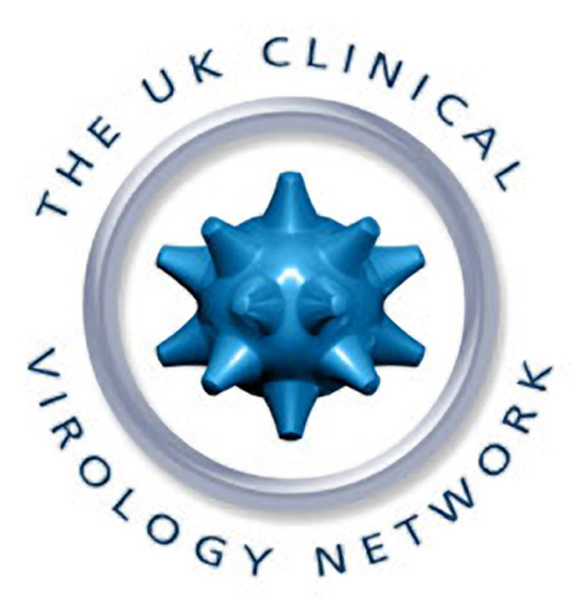

www.clinicalvirology.org

South London Specialist Virology Centre
in conjunction with
Department of Medical Microbiology

Prepared by
Dr M Sudhanva, Consultant Virologist
Mr Richard Tandy, Quality Manager
Contents

1. General information 3
1.1 Where to find Virology 3
1.2 Population served 3
1.3 Primary care 5
1.4 South London Specialist Virology Centre 5
1.5 Research 5
1.6 Surveillance activity in virology: 5
1.7 Key personnel and contact details 6
1.8 Normal laboratory opening times 7
2. Sections within the Specialist Virology Centre 7
2.1 Virus Identification Section 7
2.2 Serology 7
3. Use of the Laboratory 8
3.1 Test requesting procedure (routine, urgent and out of hours) 8
3.2 Requesting Additional Tests 8
3.3 Completing the request form 8
3.4 Specimen labelling 9
3.5 Specimen collection 9
3.6 Specimen limitations affecting assay performance 10
3.6.1 Maximum sample transport times for virology 10
3.7 Transport and receipt of specimens (including courier and postal deliveries) 10
3.8 Virology Cut-off times for receipt of specimens for a 24 hour TAT 12
3.9 High risk specimens and safety 13
3.10 Result availability 13
3.11 Telephoned results 14
3.12 Visitors 14
3.13 Issue of immunoglobulins and vaccines 14
4. Out of hours’ service 15
4.1 Out of hours’ examinations provided in virology 15
4.2 Medical advice regarding the diagnosis and treatment of infection 15
4.3 Out of hours' advice 15
5. List of examinations performed in virology 17
5.1 Viral nucleic acid tests on non-blood samples 17
5.2 Viral nucleic acid tests on blood samples 19
5.3 Virus serology including bacterial serology 20
5.4 Serology panel tests 21
6. Examinations referred to other laboratories 21
6.1 Virus sequencing and phenotyping referrals 21
6.2 Virus serology and molecular referrals 22
6.3 Atypical bacterial serology by CFT 23
6.4 Zika virus testing by referral 23
6.5 Viral nucleic acid test referrals 24
6.6 Antiviral assays 25
7. Specimen collection material and methods 25
8. External Quality Assurance (EQA) scheme participation 33

General information

Our laboratories are based at Kings College Hospital NHS Foundation Trust. We provide an extensive clinical microbiology service, including infection control services and specialist advice in microbiology, virology, parasitology and mycology to hospitals and General Practitioners. South London Specialist Virology Centre is part of the UK clinical virology network.

Epidemiological data are provided for the Communicable Disease Surveillance Centre in Colindale. Outbreaks of infectious disease are investigated in conjunction with the Consultants in Communicable Disease Control.

South London Specialist Virology Centre is UKAS accredited under the ISO 15189:2012 standards and participates in National Quality Assurance Schemes.. The schedule of accredited tests may be found by searching using the accreditation number “9863” at https://www.ukas.com/search-accredited-organisations. All non-accredited tests have a comment stating when they are not accredited.

In October 2010, we joined the KingsPath team having previously been the UK HSA London Regional Laboratory for about 20 years and along with our other colleagues have entered the joint venture with GSTS Pathology who provide pathology services at Guy’s & St Thomas’s NHS Foundation Trust. This Joint Venture was called Viapath; which is a joint venture between SERCO, Guy’s & St Thomas' NHS Foundation Trust and King’s College Hospital NHS Foundation Trust. More of the history of Viapath can be found at http://www.viapath.co.uk/about-viapath/history#sthash.7K9l2Qti.dpuf

On 1 April 2021, Guy’s and St Thomas’ and King’s College Hospital NHS Foundation Trusts have joined with SYNLAB UK & Ireland to deliver pathology services across the London 4 region as part of NHSE&I pathology network transformation.

Where to find Virology

Postal addresses

South London Specialist Virology Centre  King’s College Hospital NHS Foundation Trust  Cheyne Wing, 2nd Floor (opposite Liver ITU)  Denmark Hill  London SE5 9RS | DX address:  South London (PHL) Kings DX 6570200 Peckham 90SE

Website contacts:

www.viapath.co.uk www.clinicalvirology.org www.synlab.com

Population served

King’s College London was founded in 1829. Clinical teaching in the medical faculty was dependent on the Middlesex Hospital until 1839 when King’s College London gained its own hospital in Portugal Street, which was rebuilt in 1861. The hospital moved to the Camberwell site in 1913. It became part of the NHS in 1948 as a teaching hospital. The 1960s saw the introduction of a new dental school, maternity block (now the Ruskin Wing) and King’s liver unit. This was followed by the Normanby College of Nursing, Midwifery and Physiotherapy. In 1995 the UK’s first specialist Motor Neurone Disease Care and Research Centre was established, and the Weston Education Centre was opened in 1997, accommodating the medical school, library and lecture theatres. A new Accident and Emergency Department was opened in the same year. King’s College Hospital received Foundation Trust status on 1 December 2006. Following the dissolution of South London Healthcare Trust, King’s took over the Princess Royal University Hospital (PRUH) in October 2013.

King's College Hospital NHS Foundation Trust is a large provider of acute and specialist services that serves a population of over 1,000,000 in the economically diverse Greater London boroughs of Southwark, Lambeth and Bromley and Bexley and the county of Kent. The trust operates from 5 sites; Denmark Hill (main) site, Princess Royal University Hospital Bromley, Beckenham Hospital, Queen Mary’s Hospital Sidcup and Orpington Hospital. The Princess Royal University Hospital (PRUH) is in Farnborough, near Orpington, Kent. Beckenham Hospital is about 6 miles to the north of the PRUH and provides outpatient services. Orpington Hospital is 3 miles south of PRUH and provides outpatient services and has 40 intermediate care beds.

The trust has over 1300 beds including 1050 acute, 125 maternity and 144 critical care beds. The Denmark Hill site has approximately 836 beds including a major critical care service (122 beds) and maternity services (103 beds). Princess Royal University Hospital has 455 acute beds, 22 critical care and 22 maternity beds (plus a midwifery led birthing centre) whilst Orpington provides 29 acute beds. Emergency Department services are provided at both King's College Hospital Denmark Hill and Princess Royal Hospital. The Trust employs in excess of 10,500 staff and receives over 250,000 emergency attendances, 115,000 inpatient spells and 960,000 outpatient attendances
The trust receives over 250,000 emergency attendances, 115,000 inpatient spells and 960,000 outpatient attendances. All core services are provided from King's College Hospital Denmark Hill and Princess Royal University Hospital while outpatient and surgical services are provided from Orpington Hospital. The trust provides services to a population from the significantly deprived boroughs of Lambeth and Southwark and also the more affluent borough of Bromley. Several specialist units of international reputes offering regional or supra-regional services are located within the Denmark Hill site.
King’s College Hospital is renowned for the international reputation of its speciality services. These included the tertiary services for liver disease and transplantation, neurosciences, diabetes, cardiac services, haematology and foetal medicine. For people across south east London and Kent, King’s is the designated major trauma centre, as well as a heart attack centre and the regional hyper acute stroke centre. The new helipad at Denmark Hill, opened in November 2016, has reinforced King’s position as a major trauma centre for the south of England. King’s provides services to local residents of the London Boroughs of Lambeth, Southwark, Bromley, Bexley and Lewisham from its sites at Denmark Hill, the Princess Royal University Hospital Farnborough Common, Queen Mary’s Hospital Sidcup, and Orpington Hospital. These include accident and emergency services, maternity, care of the elderly, orthopaedics, diabetes, ophthalmology, oncology, dermatology, and many more. King’s has a reputation as pioneers in medical research, with a record of innovation in a number of key fields. The hospital is home to a number of leading clinical units and research centres, such as the Clinical Age Research Unit, the HIV Research Centre, and the Harris Birthright Centre. Developments have recently begun to build a new leading-edge Haematology Institute. King’s College Hospital NHS Foundation Trust has an enviable track record in research and development and service innovation. In partnership with King’s College London the Trust has recently been awarded a National Research Centre in Patient Safety and Service Quality. It is also a partner in two National Institute for Health Research biomedical research centres. The first is a Comprehensive centre with King’s College London and Guy’s and St Thomas’s NHS Foundation Trust and the second is a Specialist centre with the South London and Maudsley NHS Foundation Trust and the Institute of Psychiatry. King’s College Hospital NHS Foundation Trust has also recently strengthened its research and development infrastructure in order better to support clinical researchers across the organisation.
The trust has a revenue budget of £892 million (around half of which is derived from Clinical Commissioning Groups) and in 2013/14 attained an operating surplus of £60 million. Following a financially challenged 2017/18 the Trust was placed in Financial Special Measures on 11 December 2017 for breach of its NHS Provider Licence, having been in enhanced oversight for some time before that.
However, education and research are also important sources of income, currently contributing around 8% of the total. The Trust is embarking on a strategy to achieve greater diversification of its income, with growth anticipated in tertiary referrals, research and commercial services activities. There is also a developing fund raising partnership within King’s Health Partners.

The regional and supraregional services include:
- Haemato-oncology (including the UK’s largest bone marrow transplantation unit)
- Institute for Liver Studies (providing 30% of UK liver therapy, including transplantation and liver failure) for both adult and paediatric hepatology
- Variety Club Children’s Hospital
- Regional Neurosciences and Neurosurgical services
- Renal unit (offering dialysis including HBV, HCV and HIV positive individuals)
- Harris Birthright Centre for Fetal Medicine
- Adult Intensive Care Units, neonatal and paediatric intensive care and high dependency units
- Solid tumour oncology / cancer services (including skin, hepatobiliary, head and neck)
- Cardiac surgery (regional)
- South East London Major Trauma Centre
- Paediatric and adult Accident and Emergency departments
- Obstetrics and gynaecology; assisted conception
- Genito-urinary medicine (Caldecot Centre)
- Reproductive and Sexual Health

Primary care
The laboratory serves more than 100 fund-holding general practitioners. The response of King’s College Hospital to the evolving Primary Care Groups and Trusts has resulted in further demands on the clinical virology service. The King’s local Primary Referral Guide reflects general practitioners’ expectations of direct access for prompt clinical advice, including virological advice. Specialist virology services and clinical advice are offered by virology to the London Boroughs of Lambeth, Southwark, Lewisham, Bromley, Bexley and Greenwich. The local authorities serviced by the laboratory are the London Boroughs of Bromley, Southwark, Bexley and Greenwich.

South London Specialist Virology Centre

The medical virologists include two consultant virologists and one part-time consultant and a specialty trainee, who work closely with a large lab team. This larger team consists of a Principal Clinical Scientist, Clinical Scientist, team of Biomedical Scientists and Scientific Assistant Technical Officers, supported by a Health & Safety Manager, a Quality Manager and Administrative & Clerical team. They in turn report eventually to the Service Delivery Manager and General Manager. Together, the team manages a workload of about 345,000 tests per annum, of increasing complexity and requiring sophisticated laboratory processing and interpretation. The routine diagnostic work includes general serology, hepatitis and retrovirus serology, and an extensive repertoire of molecular based tests which include both qualitative and quantitative assays as well as antiretroviral resistance testing using automated sequence analysis, employing a range of different platforms and technologies underpinned by our Service Development research. General microbiology serological tests which are sent to the combined department are carried out in virology. In addition, all Chlamydia trachomatis and N gonorrhoea tests are carried out by APTIMA (TMA) technology on genital swab / urine samples. Virology receives specimens from an increasing number of external microbiology laboratories for investigation. The department also processes >500 dried blood spot cards per week for HIV, HBsAg, HB core total antibody, HCV antibody and HCV RNA.

The current capacity of the laboratory is to process 3000 combined nose and throat swabs for SARS-CoV-2 RNA as routine.

Research
There are collaborations between clinical research groups and academic partners at Guy's, King's, and St Thomas’s School of Medicine, the Institute of Psychiatry, The School of Nursing and Midwifery, King's College London and King's Division of Biomedical Sciences. King's College Hospital Foundation Trust is alongside King’s College London, Guy’s and St Thomas’ and South London and Maudsley Foundation Trusts members of King’s Health Partners, an Academic Health Science Centre.

Research interests in the laboratory include:

There is a small team of clinical scientists work in collaboration with medical and biomedical scientist colleagues in a variety of projects including technology transfer to the routine diagnostic service as well as other academic research activities. Work carried out in the both microbiology and virology departments has been published in numerous peer-reviewed journals and presented at local, national and international meetings.

Surveillance activity in virology:

HIV HIV antiretroviral resistance data sequence for MRC database, HIV avidity for RITA programme
HCV Reporting to the National HCV sentinel surveillance study
Norovirus Diagnosis and outbreak analysis
Influenza Diagnosis and typing
Pregnancy Screening in pregnancy

South London Specialist Virology Centre and Department of Microbiology [together as Infection Sciences] provide a full screening service for NHS Infectious Diseases in Pregnancy Screening [IDPS] Programme.

Key personnel and contact details

Virology direct lines: Results Phone: External 020 3299 6155 Internal 36155
Medical advice: External 020 3299 6298 Internal 36976 / 36977 / 36978

Microbiology Phone: ` External 020 3299 3213 Internal 33565
Virology and Microbiology Fax: External 020 3299 3404

Virology only - 020 3299 + 9000 (switch) or extension
Designation | Name | Telephone extension
Head of Virology - Consultant Virologist  Laboratory Director | Dr Mark Zuckerman | 36298 / 36970
Consultant Virologist | Dr M Sudhanva | 36298 / 36971
Consultant Virologist /Infectious Diseases Physician | Dr Temi Lampejo | 36298 / 36295
Virology Operations Manager | Diana Bate | 36159
Higher Specialty Trainee or  Combined Infection Trainee | Trainee on rotation | 36298
Microbiology and Virology common staff - 020 3299 + 9000 (switch) or extension
Service Delivery Manager | Gary Nicholson/ Victoria Aruldoss-Hines/ Fearghal Tucker | 33549
Principal Clinical Scientist | Dr Melvyn Smith | 36155
Clinical Virology Systems Implementation Manager and Clinical Scientist | Ian Butler | 36159
Laboratory Administrator | Vacant | 36260
Departmental Secretary for Medics | Anna Maria Gomez-Danso | 33565
Virology Admin team | Lydia Kimotho / Julie Kenny / Michelle Wallis | 36155
Microbiology Operational Manager | Katy Stocker | 31579
Quality Manager | Vacant | 36140

Microbiology only - designation | Name
Clinical Lead for Infection Sciences and Consultant Microbiologist | Dr Martin Brown
Lab Director, Infection Control doctor and Consultant Microbiologist | Dr Carmel Curtis
Consultant Microbiologist and Synlab Strategic Clinical Lead | Dr Silke Schelenz
Consultant Microbiologist | Dr Julia Colston
Consultant Microbiologist | Dr Anita Verma
Consultant Microbiologist & Infectious Diseases consultant | Dr Maurico Aras
Consultant Microbiologist & Infectious Diseases consultant & Local Faculty Lead for Medical Microbiology and Infectious Diseases | Dr Hector Maxwell-Scott
Consultant Microbiologist & Infectious Diseases consultant | Vacant
Consultant Microbiologist & Infectious Diseases consultant | Vacant
Consultant Microbiologist (PRUH) | Dr Mustafa Atta
Consultant Microbiologist (PRUH) | Dr Sumati Srivastava
Consultant Microbiologist (PRUH) | Vacant

Normal laboratory opening times

Routine specimens are accepted at the virology laboratory from is Monday to Friday: 9 AM to 5 PM

Sections within the Specialist Virology Centre

There are two diagnostic sections viz. Virus Identification Section and Virus Serology.

Virus Identification Section

Virus detection by molecular techniques is now a routine service daily Monday to Friday for many viral infections. Some are also performed during winter over the weekend. Please note we no longer provide virus isolation or direct immunofluorescence (DIF) diagnostic services. Samples for electron microscopy (EM) are referred to another laboratory if needed.
Molecular diagnostics use real time PCR for the detection of viral nucleic acid in clinical samples. Nucleic acid tests performed routinely are for the detection / quantification of:
Viruses in blood (HCV RNA, HIV-1 RNA, HBV DNA, HEV RNA, BKV DNA, adenovirus DNA, CMV DNA and EBV DNA)
Respiratory viruses (influenza viruses, RSV, parainfluenza viruses, rhinovirus, metapneumovirus and adenovirus)
Other body sites/fluids (HSV DNA, VZV DNA, adenovirus DNA, enterovirus RNA, JCV DNA, BKV DNA, HHV6 DNA)
Gastroenteritis viruses (norovirus and rotavirus RNA)
Sexually transmitted infection (C. trachomatis & N gonorrhoea DNA and HSV DNA)
Multiplex PCR’s are available for the following viruses as routine testing of all respiratory samples along with stand-alone adenovirus DNA testing:-
Multiplex 1: influenza A virus, influenza B virus and human metapneumovirus,
Multiplex 2: RSV subgroup A and B, rhinovirus
Multiplex 3: parainfluenza viruses 1, 2 and 3
Multiplex 4: influenza A virus CDC matrix and pandemic influenza A H1N1 (2009)v H1

Diagnosis of atypical bacteria and coronaviruses is by molecular-based GenMark ePlex. SARS-CoV-2 RNA by Cepheid GeneExpert which are available for urgent 24/7 testing of respiratory viruses and atypical bacteria. Its current usage is to exclude pertussis and the occasional virus in the critically unwell patient or respiratory-wise severely ill patients who are scheduled for a transplant.
Antiretroviral resistance testing in HIV by nucleic acid sequencing for resistance testing are also provided.

Serology

The serology section detects antibodies to viruses and viral antigens in serum using automated assays. In addition, a few bacterial antibodies are also assayed in this section. Automated machines include TECAN, Abbott Architect and VIDAS.

Use of the Laboratory

Test requesting procedure (routine, urgent and out of hours)
Routine requests can be made either by King’s EPR system or any virology / microbiology request form. During normal laboratory hours please telephone urgent requests (020 3299 6155 or speak to the medical staff on 36298) to ensure priority processing. See section 3 for use of on-call services.

Requesting Additional Tests

Sample Type | Time limit for requesting  extra tests
Genital and urine samples for Chlamydia trachomatis + N. gonorrhoeae | 14 days
Non-Blood Samples
CSF | 28 days
Fluids | 28 days
Swabs | 28 days
Faeces | 28 days
Dry tissue (Skin and Nails) | 28 days
Respiratory tract samples | 28 days
Wet tissue | 42 days
Dried Blood Spot Cards | 4 months
Plasma
Medico-legal | 30 Years
HIV viral loads (>20 copies/ml) | 30 Years
Whole blood samples | 7 days
Other plasma | 14 days
Serum
Other sera | ~ 1 Year
Medico-legal | ~ 2 Years
Pregnant booking | 2 Years
Needlestick injuries | 30 Years
Pre-transplantation (donor) sera | 30 Years

All post-mortem tissues are returned to histopathology when testing is complete. For specific enquiries please contact the medical staff.

Completing the request form
Please use labels whenever possible.

EPR requests:
All Denmark Hill site patient sample requests can be made via EPR (except Caldecot Centre and Occupational Health.) Please free text in the clinical details field if you cannot see an intended test on EPR request.
Please telephone 36298 for specimens to be processed urgently.

Electronic requests from Caldecot Centre / Reproductive and Sexual Health
Since 2018, all requests are electronic

Electronic requests from GPs
Many GP surgeries within the vicinity of King’s send samples with electronic forms using T-Quest system.
Please telephone 0203 299 6298 for specimens to be processed urgently.

Types of paper-based request forms:
Blue virology form ⇨ ⇨ ⇨ King’s College Hospital usage [emergency usage only]
Multipart single pathology request ⇨ ⇨ GP use (GPs who are not part of T-Quest system)
Dried bloodspot forms ⇨ ⇨ ⇨ Alere

Any hand written form should be completed legibly.

Please telephone 36298 for specimens to be processed urgently.

Minimum Required Data:

Either and EPR-based or a paper-based request must accompany all specimens sent to the laboratory. It should clearly state the following information.

Those in bold are a minimum requirement and without them the sample could be discarded or delayed.
Patient name
Unit number/NHS number
Date of birth (age if DOB not known)
Sex
Ward or Address for report
Requesting Medical Officer/GP name and number
Date and time specimen taken
Type of specimen (Specify anatomical site from which vesicle swab / fluid specimens were taken)
Tests required

Other useful data
Bleep number or mobile number, in order to phone results both before 5 PM and after 5 PM results
Patient address
All relevant clinical details including
any antimicrobial treatment (recent, current and intended)
History of foreign travel including return dates, countries/regions visited
Date of onset and duration of illness, particularly for serology
Useful epidemiological information, e.g.:
Children and suspected influenza - give the name of the school
Adults and suspected norovirus - give the place and type of work, (e.g., catering, cruise liner
All patients and suspected viral haemorrhagic fever – travel destination, date of return, date of onset of illness, signs and symptoms, malaria smear
Viral Haemorrhagic Fever Risk status if applicable – MUST BE DISCUSSED WITH MEDICAL VIROLOGY STAFF FOR RISK ASSESSMENT BEFORE SENDING SAMPLE

If uncertain about the exact test and terminology, please give a detailed clinical history as this can help the Virology medical staff to decide the most appropriate investigations.

Incorrectly labelled specimens / forms will not be processed as we cannot guarantee that the sample and form match and that the patient identity.

Specimen labelling

- Use labels wherever possible.
- The specimen must be labelled with the same patient details as those on the request form
- Please ensure the full patient name and the date of sample collection are legible
- Please note that unlabelled specimens do not guarantee authenticity of the sample and these cannot be processed and will be discarded.

Specimen collection

The best results are obtained when an appropriate, well-taken specimen is in the proper container, is delivered to the laboratory promptly and relevant clinical information is provided on the request form. Please contact the laboratory if there is any doubt about the best specimen to take or you have questions about any test.

General guidelines on specimen collection include:
Send specimens in sterile containers
Collect specimens from the actual site of suspected infection. Please do not send just blood samples for ‘viral serology’ instead of vesicular fluid or throat swab or CSF, as the case may be.
Take specimens that are representative of the disease process. For example, respiratory specimens are more appropriate than blood for serology in cases of acute respiratory infection.
An adequate quantity of material should be obtained for complete examination especially vesicle fluid, CSF and NPA
Take care to avoid contamination of the specimen by microorganisms normally found on the skin and mucus membranes. Sterile equipment and aseptic technique must be used for collecting specimens, particularly for those from normally sterile sites
All swabs or material from swabs should be immersed in virus transport medium (VTM) and transported promptly to the laboratory. Viruses including (viral nucleic acid) may not survive prolonged storage at room temperature or may be overgrown by bacteria or fungi.
In the absence of readily available VTM (laboratory issued or commercial), please immerse the swab tips in 1 ml of sterile saline in an universal container

Specimen limitations affecting assay performance

Factors that can affect assay performance are as follows
inherent (age, gender, nutritional status, pregnancy, congenital immunological defects)
acquired (passively acquired antibody, immune response to immunisation, immunosuppression)
biological (lipaemic, haemolysed, high bilirubin content e.g. Liver ITU patients)
collection container (use of correct blood collection tubes – e.g. serum from clotted blood may underestimate HIV-1 RNA load when compared to EDTA plasma)
Sample volume, collection and transportation
Time of sample collection to receipt in laboratory

3.6.1 Maximum sample transport times for virology

Sample Type | Maximum Transport time at Ambient Temperature
Genital and urine samples for Chlamydia trachomatis + N. gonorrhoeae | 30 days
Non-Blood Samples
CSF | 3 days
Fluids | 3 days
Swabs in Universal Transport Medium | 3 days
Faeces | 3 days
Dry tissue (Skin and Nails) | 3 days
Respiratory tract samples | 3 days
Wet tissue | 3 days
Dried Blood Spot Cards | 3 days
Whole blood samples | 3 days
Other plasma | 3 days
EDTA – quantitative and qualitative molecular | 3 days

Transport and receipt of specimens (including courier and postal deliveries)

Samples must be delivered to the department in a way to protect the integrity of the sample. Samples must not be exposed to extreme temperature or prolonged transport. If samples are in danger of being exposed to conditions where sample integrity can be compromised, please contact the laboratory to discuss the most appropriate method of transport.

When receiving samples from an external institution or laboratory, it is the responsibility of the sender to ensure that the samples are packed in accordance with the current postal regulations, contain appropriate paper work and are labelled correctly. Courier / taxi / suitable transport should be arranged by sending institution or laboratory. You may have to contact the on-call BMS staff for out-of-hours’ testing to indicate approximate time of arrival of sample at virology. Our experience shows that a considerable amount of time is wasted by our on-call BMS staff just waiting for a sample to arrive because of lack of communication from the test requesting person.

ROUTINE SAMPLES:
During normal working hours, all routine King’s specimens should be taken to central specimen reception at King’s College Hospital or be sent via Pneumatic Air Tube Transport System (PATTS).
There is a RED BOX at virology / microbiology reception which can accept deposits of respiratory samples meant for SARS-COV-2 RNA testing 24/7

The following ‘virology’ specimens must not be sent via the air tube:
  - any respiratory tract specimen (sputum, bronchoalveolar lavage, respiratory aspirates)
  - any specimen from patients known to have, or thought to have:
    - transmissible spongiform encephalopathy (CJD, GSS etc.)
    - a viral haemorrhagic fever (eg Lassa virus, Ebola virus etc.)
  - any difficult to resample or unrepeatable specimen of any type

URGENT SAMPLES:
During working hours: for urgent testing, bring the specimen DIRECTLY to the laboratory reception, which is on the 2nd floor of Cheyne Wing (opposite Liver ITU). Please telephone 36298 for specimens to be processed urgently during working hours.
Urgent SARS-COV-2 RNA by either Cepheid or GenMark ePlex are controlled by Trust-based Silver Command protocols. ED, Cardiac Theatres and ITUs do send samples for urgent SARS-CoV-2 RNA.

During out-of-hours: urgent sample processing for non- SARS-COV-2 RNA is via discussion with Medical Virologist on- call. If within Denmark Hill site, please collect the sample and retain it in the ward; our on-call BMS will physically collect the sample from the ward in order to avoid misplaced and lost sample situations.

Urgent SARS-COV-2 RNA by either Cepheid or GenMark ePlex are controlled by Trust-based protocols and if out with this, by Trust’s Silver Command.

Do not send samples to Central Specimen Reception for urgent testing, but contact the laboratory or the on-call BMS staff (07720 275 661) for directions before arranging urgent transport to laboratory reception.

Virology Cut-off times for receipt of specimens for a 24 hour TAT

If a sample needs to be processed urgently based on clinical ground, please contact the medical virologist on-call / on duty as detailed in section 3.3.

Virology cut-off times for processing samples for a 24-hour TAT
Specimen type | Assays | Cut-off time for processing | Results available at: | Samples not processed on:
Respiratory samples  Respiratory samples  (Combined throat and nasal swab, BAL, NPA, ETA etc.) | SARS-CoV-2 Routine Altona Real Star  (see section 5.1 below) | 24/7 | Within 24 hours | None
 | SARS-CoV-2 Urgent Cepheid GenExpert  (see section 5.1 below) | 24/7 | Within 1.5 hours | None
 | GenMark ePlex panel for 20 viruses and 3 bacteria  (see section 5.1 below) | 24/7 | Within 2 hours | None
 | Routine 11-virus panel (not including SARS-CoV-2) | 12 noon | 4.30 PM | Saturdays when respiratory activity is low.
 | Routine 11-virus panel (not including SARS-CoV-2) | 2 PM  (Winters) | 10 AM next day
Faeces or rectal swab in VTM or vomitus | Adenovirus DNA (faecal)  Astrovirus RNA  Norovirus RNA  Rotavirus RNA  Sapovirus RNA | 10 AM | 3.30 PM | Saturdays when norovirus activity is low.
Faeces or rectal swab in VTM or vomitus |  | 3PM (Winters) | 10 AM next day
CSF | HSV DNA,  VZV DNA,  enterovirus RNA,  parechovirus RNA  See below for CMV and EBV DNA | 10 AM | 3.30 PM | Weekends and Bank Holidays.
Vesicle fluid | HSV DNA, VZV DNA and enterovirus RNA | 10 AM | 3.30 PM | Weekends and Bank Holidays.
EDTA whole blood | CMV DNA, EBV DNA and adenovirus DNA | 3 PM | 1 PM next day | Weekends and Bank Holidays.
EDTA plasma | HIV-1 RNA and  HCV RNA | 3 PM | 1 PM next day | Weekends and Bank Holidays.
Eye swab | HSV DNA, VZV DNA and adenovirus DNA | 10 AM | 3.30 PM | Weekends and Bank Holidays.
Any in-house serology | See section 3.1, 3.3 and 5.3 | Any time | Varied | Weekends and Bank Holidays, except for On-call work (see 3.1 and 3.3)

High risk specimens and safety

Pathogens are classified in hazard groups 1 to 4, with hazard group 1 being non-pathogenic to humans and hazard group 4 the most dangerous pathogens to humans.

Samples from patients with suspected viral haemorrhagic fevers, with a history of having returned within 21 days from Africa, Asia and South America are considered high risk. Contact virology medical staff before taking ANY sample. Special transport arrangements of these samples will be made in conjunction with Rare and Imported Pathogens Laboratory (RIPL), UK HSA Public Health England, Porton Down, SP4 0JG

All blood samples are handled safely in the laboratory and consequently we do not require “DANGER OF INFECTION” labels. It is the responsibility of the sender to package samples safe enough for transportation according to regulations.

We assume all respiratory samples may potentially contain a hazard group 3 pathogen and treat samples accordingly.

Great care must be taken in obtaining specimens. Equipment such as needles and blades must be immediately disposed of safely in locally approved "sharps" bins and NOT SENT TO LABORATORIES. Specimens should be transported to the laboratory without delay.

Result availability

Serology |  | Molecular
Qualitative | Quantitative | Qualitative | Quantitative
- Positive  - Negative  - Indeterminate  - Insufficient  - Confirmed by neutralization | - Quantitation with appropriate units (e.g mIU/ml)  - Less than the lower limit of detection (e.g <10 mIU/ml) | - Positive  - Negative  - Inhibitory  - Positive at limit of detection  - Insufficient | - Quantitation with appropriate units and log value  - Less than the lower limit of detection  - Positive (unable to quantify)  - Inhibitory  - Insufficient

As a rule, we do not issue Reactive / Non-reactive / Detected / Not detected / Low positive / High Negative / Equivocal results.

This rule is based on
- possible misinterpretation of results by clinicians and to prevent Serious Untoward Incidents (see “transplant team had misheard "reactive" as "nonreactive" in reference to the donor testing HIV-positive” http://edition.cnn.com/2011/HEALTH/08/30/taiwan.transplant.hiv/).
- NHS Organ Donation and Transplantation have also recommended using these terminologies (http://www.odt.nhs.uk/pdf/microbiological_screening_in_organ_donation_an_overview_part2.pdf).

Exporting of reports:
- Electronic reports are exported to EPR within 100 seconds of authorising.
- Most GP results are returned via GP links (TQuest) but those not on registered on the system are returned as a printed hard copy.
- Camberwell Sexual Health Clinic results are electronically returned and are available in Cyberlab.
- Third party contract results are available either on results on line, Cyberlab or printed hard copy depending on the negotiated contract.
- South London and Maudsley results are electronically returned.
- Non-EPR reports are printed and dispatched every working day – Monday to Friday. The speed of reporting depends on the frequency of testing and the urgency of the request.
- Copies of printed reports can be obtained by telephoning extension 36155. Reports are never faxed.
- Organ donor test results are emailed as PDF documents by secretaries and On Call BMS.

Telephoned results

Significant positive and negative results, urgent requests and rapid requests that may aid the immediate patient management will be telephoned by medical virologists to clinical teams within the Denmark Hill site. However, for District General Hospitals and GP surgeries, Virology BMS or Clerical Team members will call the corresponding laboratory or nursing staff to convey the results.

Examples include (this is not an exhaustive list):
- Respiratory virus detection by PCR in a respiratory sample.
- CSF nucleic acid test positive result
- Any acute infection diagnosis
- Blood borne virus infection such as new HIV, acute HBV, acute HAV and first HTLV

Visitors

Visitors should introduce themselves at the laboratory reception (2nd floor, Cheyne Wing, opposite Liver ITU). The person they wish to see will come to meet them. It is best to make appointments in advance to ensure the right person is available.

Issue of immunoglobulins and vaccines

As of 1 October 2021, the laboratory has stopped having stocks of varicella zoster immunoglobulin (VZIG) and hepatitis B immunoglobulin (HBIG as 500 IU vials).
All requests for VZIG will be on a ‘named patient’ basis via the Rabies and Immunoglobulin Service RIGS at UK HSA Colindale and if indicated will be issued from the centrally held stock at Movianto through ImmForm.
Before contacting RIGS one has to check if request falls within the Guidance

Routine service for RIGS
RIgS operates between 8am to 5.30pm Monday to Friday. All requests for replacement vaccine and advice about issuing should be directed to this service (Tel: 0330 128 1020).
Requests for immunoglobulin/vaccine Monday to Friday will be ordered through Movianto for delivery to a named responsible clinician to arrive the next working day before 2pm. However, there may occasionally be specific urgent situations where HRIG is needed sooner than this, and in these circumstances UK HSA can issue immunoglobulin through a more rapid delivery.
Out of hours service for RIGS
Clinical advice is available through the Colindale Duty Doctor service, between 9am and 7pm at weekends and bank holidays. Most calls can wait until the next day, so callers after 5:30pm are encouraged to call back the next morning to speak to RIgS or the Colindale Duty Doctor service (see Table 1). Vaccine should be sourced locally, and will be replaced through RIgS the next working day. There is no need to talk to the RIgS team or Colindale before arranging this.
If HRIG is required out of working hours and cannot wait until the next working day, the product may be able to be collected from a local stock-holder or be issued out of hours for delivery the next day. Arrangements for urgent delivery on non-working days should be made by calling the Duty Doctor between 9am and 7pm.
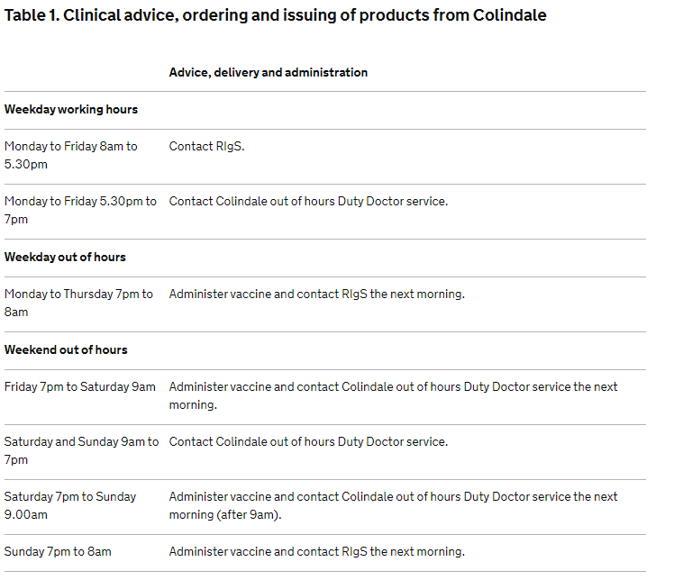

Out of hours’ service

Out of hours’ examinations provided in virology

An on-call service is provided from 5pm to 9am Monday to Friday, all day Saturday, Sunday and bank holidays. For urgent specimen testing, contact the doctor or BMS on-call through the KCH switchboard (020 3299 9000).

Transplant coordinators should contact the King’s College Hospital switchboard (020 3299 9000) and ask for the on call biomedical scientist.

Urgent / out of hours’ requests in virology

Assays / samples | Specimen type | Turnaround time
HIV 1 & 2 antibody / antigen | 10 ml clotted blood | 2 hours
Hepatitis A virus IgM | 10 ml clotted blood | 2 hours
Hepatitis B surface antigen | 10 ml clotted blood | 2 hours
Hepatitis B core total antibody | 10 ml clotted blood | 2 hours
Hepatitis B core IgM antibody | 10 ml clotted blood | 2 hours
Hepatitis B surface antibody | 10 ml clotted blood | 2 hours
Hepatitis C virus antibody | 10 ml clotted blood | 2 hours
HTLV I & II antibody | 10 ml clotted blood | 3 hours
CMV IgG antibody | 10 ml clotted blood | 2 hours
Measles virus IgG | 10 ml clotted blood | 4 hours
Varicella zoster virus IgG | 10 ml clotted blood | 4 hours
Norovirus RNA | Faeces | 5-29 hours
Respiratory GenMark ePlex panel for 20 viruses and 3 bacteria [including SARS-CoV-2 and MERS-CoV RNA] | Any respiratory sample | 90 minutes
SARS-CoV-2 RNA only | Any respiratory sample | 90 minutes

Other tests can be carried out after discussion with one of the medical virologists. An example of this is the diagnosis of atypical bacteria and coronaviruses by molecular-based GenMark Eplex, which is available for urgent 24/7 testing. GenMark Eplex. It is available at Denmark Hill site. Its current usage is likely to exclude pertussis and SARs-CoV-2 RNA in the critically unwell patient or respiratory-wise ill patients who are scheduled for a transplant. Access to this testing is by discussion with a Consultant Microbiologist or Consultant Virologist.

Medical advice regarding the diagnosis and treatment of infection

During weekdays from 9 am to 5 pm medical advice on interpretation of virology results, antiviral management, blood borne virus exposure incidents and post exposure prophylaxis or any other relevant clinical circumstance can be sought from the virology specialist registrars or consultants on extension 36298.

Infection control advice can be obtained from the Infection Control Nurses on extension 34374 or the Kings Web. During out of hours, please call the on-call doctor preferably during the day.

Please DO NOT CALL 36298 to obtain RESULTS (for results please call 36155).

Out of hours' advice

An on-call service is provided by the Virology from 5pm to 9am Monday to Friday, all day Saturday, Sunday and bank holidays. To send urgent samples to Virology, please contact the King’s College Hospital switchboard (020 3299 9000) and ask for the on call biomedical scientist (07720 275 661). It is better logistically to keep the samples in the wards and not use Porters to bring the sample to Virology during the out of hours.

The on-call biomedical scientists will not look up results out of hours unless discussed and agreed with the medical virology staff.

Out of hours - a Specialist Registrar and/or Consultant Virologist can be contacted via KCH switchboard to discuss clinical, diagnostic and therapeutic problems with doctors.

Appropriate specimens for urgent examination on-call include:

Urgent nasopharyngeal aspirate / BAL investigation for respiratory viruses
Urgent duplicate combined throat and nasal swabs for avian influenza A H5N1 virus
Screening of organ transplant donors
Screening of organ transplant recipients who are urgently listed
Returning travellers on renal dialysis
Other tests are available after consultation with medical virology staff
Faeces or vomitus for norovirus RNA

List of examinations performed in virology

Viral nucleic acid tests on non-blood samples

Specimen type | Tests performed | Availability | Maximum TAT from receipt of sample during working week
- Combined nose and throat swab in VTM  - Broncho-alveolar lavage  - Bronchial lavage  - Nasopharyngeal aspirate  - Endotracheal aspirate | SARS-CoV-2 RNA only (Altona RealStar assay) S and E gene ROUTINE | Every day  3000/day capacity
 | SARS-CoV-2 RNA N2 and E gene URGENT Cepheid GenExpert | 24/7  Trust Silver Command protocol led demand  10/day capacity | 1.5 hours
 | GenMark ePlex panel for 20 viruses and 3 bacteria  - Adenovirus DNA  - Coronavirus 229E RNA  - Coronavirus HKU1 RNA  - Coronavirus NL63 RNA  - Coronavirus OC43 RNA  - SARS-CoV-2 RNA  - MERS-CoV RNA  - Human Metapneumovirus RNA  - Human Rhinovirus/Enterovirus RNA  - Influenza A virus RNA  - Influenza A virus H1 RNA  - Influenza A virus H1-2009 RNA  - Influenza A virus H3 RNA  - Influenza B virus RNA  - Parainfluenza virus 1 RNA  - Parainfluenza virus 2 RNA  - Parainfluenza virus 3 RNA  - Parainfluenza virus 4 RNA  - RSV subgroup A RNA  - RSV subgroup B RNA  - Bordetella pertussis DNA  - Legionella pneumophila DNA  - Mycoplasma pneumoniae DNA | 24/7  Trust Silver Command protocol led demand  125/day capacity | 2 hours
 | ROUTINE IN-HOUSE panel for 10 viruses  - Influenza A virus RNA  - Influenza B virus RNA  - Human metapneumovirus RNA  - Parainfluenza 1 virus RNA  - Parainfluenza 2 virus RNA  - Parainfluenza 3 virus RNA  - Respiratory syncytial virus (RSV) subgroup A RNA  - Respiratory syncytial virus (RSV) subgroup B RNA  - Rhinovirus RNA  - Adenovirus DNA | Once a day.  150/day capacity | 15 hours
 | Influenza A virus Oseltamivir resistance H275Y mutation | Whenever necessary  [Sent away] | 2 weeks
- Genital swab in VTM  - Endocervical swab in VTM  - urine in universal  - urethral swab | HSV 1 & 2 DNA  VZV DNA | Daily (weekdays) | 2 days
 | HSV drug resistance testing | Whenever necessary  [Sent Away] | 4 weeks
- Genital swab in APTIMA swab  - Endocervical swab in APTIMA  - urine (first catch urine)  - urethral swab in APTIMA swab | Chlamydia trachomatis DNA  Neisseria gonorrhoea DNA | Daily (weekdays - [Sent Away] to PRUH Microbiology) | 5 days
Eye / conjunctival / corneal swab in VTM | Adenovirus DNA  HSV 1 & 2 DNA  VZV DNA | Daily (weekdays) | 2 days
Eye / conjunctival / corneal Swab in VTM | Chlamydia trachomatis DNA | Daily (weekdays) | 2 days
CSF | Adenovirus DNA  CMV DNA  EBV DNA  Enterovirus RNA  Parechovirus RNA  HSV 1 & 2 DNA  Parechovirus RNA  VZV DNA | Daily (weekdays) | 2 days
CSF | JC virus DNA  HHV 6 DNA | Twice weekly | 14 days
CSF | HIV-1 RNA | Daily (weekdays) | 3 days
- Faeces  - Rectal swab in VTM | Adenovirus DNA (faecal)  Astrovirus RNA  Norovirus RNA  Rotavirus RNA  Sapovirus RNA | Daily (weekdays)  Weekly | 2 days  14 days
- Urine  - EDTA blood | Adenovirus DNA  BK virus DNA  CMV DNA | Daily (weekdays)  Daily (weekdays)  Twice weekly | 2 days  2 days  7 days
Skin Swab in VTM | Enterovirus RNA  HSV 1 & 2 DNA  VZV DNA | Daily (weekdays) | 2 days
Skin vesicle swab in VTM | HSV 1 & 2 DNA  VZV DNA | Daily (weekdays) | 2 days
Tissue / Biopsies | Site specific investigations | Daily (weekdays) | 3 days
- Mouth swab in VTM  - Saliva swab | Measles virus RNA  Mumps virus RNA  Rubella virus RNA | Send away to Cambridge UK HSA | 7 - 14 days

Viral nucleic acid tests on blood samples

Molecular assays on blood
Test | Specimen type | Schedule | Maximum turn round time from receipt of sample during working week
Adenovirus DNA - quantitative | 10ml EDTA blood | Daily (weekdays) | 2 days
BK virus DNA - quantitative | 10ml EDTA blood | Twice weekly | 3 days
CMV DNA - quantitative | 10ml EDTA blood | Daily (weekdays) | 2 days
EBV DNA - quantitative | 10ml EDTA blood | Daily (weekdays) | 2 days
Enterovirus RNA | 10ml EDTA blood | Daily (weekdays) | 3 days
HBV DNA - quantitative | 10ml EDTA blood | Weekly | 7 days
HBV DNA antiviral drug resistance | 10ml EDTA blood | Whenever necessary | 30 days  [Sent away]
HCV RNA - quantitative | 10ml EDTA / clotted | Daily (weekdays)  Centrifuged within  24 hours of collection | 5 days
HCV RNA viral - qualitative | DBS | Daily (weekdays) | 5 days
HDV RNA - quantitative | 10ml EDTA blood | Sent away | 7 days
HEV RNA - quantitative | 10ml EDTA blood | Twice weekly | 3 days
HHV 6 DNA - quantitative | 10ml EDTA blood | Sent away | 7 days
HHV 7 DNA - quantitative | 10ml EDTA blood | Sent away | 7 days
HHV 8 DNA - quantitative | 10ml EDTA blood | Sent away | 7 days
HIV-1 antiretroviral resistance – Integrase region | 10ml EDTA blood | Weekly | 14 days
HIV-1 antiretroviral resistance RT and Protease regions | 10ml EDTA blood | Weekly | 14 days
HIV-1 CCR5 / CXCR4 tropism assay trofile assay | 10ml EDTA blood | Weekly | 14 days
HIV-1 proviral DNA - qualitative | 10ml EDTA blood | Sent away | 20 days
HIV-1 RNA - quantitative | 10ml EDTA blood | Daily (weekdays)  Centrifuged within 24 hours of collection | 3 days
HIV-2 antiretroviral resistance | 10ml EDTA blood | Sent away | 14 days
HIV-2 proviral DNA - qualitative | 10ml EDTA blood | Sent away | 20 days
HIV-2 RNA - quantitative | 10ml EDTA blood | Sent away | 20 days
HSV 1 and 2 DNA - qualitative | 10ml EDTA blood | Daily (weekdays) | 2 days
HTLV proviral DNA - qualitative | 10ml EDTA blood | Sent away | 20 days
VZV DNA - qualitative | 10ml EDTA blood | Daily ( weekdays) | 2 days

Virus serology including bacterial serology

Test | Laboratory testing this | Clotted blood as primary sample* | Alternate samples | Schedule | Maximum turn round time during working week
CMV IgG | Virology | 10 ml |  | Daily | 3 days
CMV IgG avidity | Virology | 10 ml |  | Daily (weekdays) | 3 days
CMV IgM | Virology | 10 ml |  | 2 - 3 times a week | 3 days
EBV VCA IgG | Virology | 10 ml |  | Daily (weekdays) | 3 days
EBV VCA IgG avidity | Virology | 10 ml |  | Daily (weekdays) | 3 days
EBV VCA IgM | Virology | 10 ml |  | 2 - 3 times a week | 3 days
Hepatitis A virus IgG | Virology | 10 ml |  | Daily | 3 days
Hepatitis A virus IgM | Virology | 10 ml |  | Daily | 2 days
Hepatitis B core IgM | Virology | 10 ml |  | As required | 3 days
Hepatitis B core total antibody | Virology | 10 ml | DBS | Daily | 2 days
Hepatitis B e antibody | Virology | 10 ml |  | As required | 3 days
Hepatitis B e antigen | Virology | 10 ml |  | As required | 3 days
Hepatitis B surface antibody | Virology | 10 ml |  | Daily | 2 days
Hepatitis B surface antigen | Virology | 10 ml | DBS | Daily | 2 days
Hepatitis B surface antigen confirmation by neutralisation | Virology | 10 ml |  | Daily | 3 days
Hepatitis B e antigen confirmation by neutralisation | Virology | 10 ml |  | Daily | 3 days
Hepatitis C virus antibody/antigen | Virology | 10 ml | DBS | Daily | 2 days
HEV IgG | Virology | 10 ml |  | Twice weekly | 3 days
HEV IgM | Virology | 10 ml |  | Twice weekly | 3 days
HIV antibody - confirmation | Virology | 10 ml |  | Daily | 2 days
HIV-1 and 2 antibody / antigen | Virology | 10 ml | DBS, Saliva | Daily | 2 days
HSV type specific IgG | Barts | 10 ml |  | As required | 4 days
HTLV 1 and 2 antibody | Virology | 10 ml |  | Daily | 3 days
Measles virus IgG | Virology | 10 ml |  | As required | 5 days
Measles virus IgM | UK HSA Cambridge | 10 ml |  | As required | 14 days
Mumps virus IgG | Virology | 10 ml |  | As required | 5 days
Mumps virus IgM | UK HSA - Colindale | 10 ml |  | As required | 14 days
Parvovirus B19 IgG | Virology | 10 ml |  | 1 - 2 times a week | 4 days
Parvovirus B19 IgM | Virology | 10 ml |  | 1 - 2 times a week | 4 days
Rubella virus IgG | Virology | 10 ml |  | Daily | 2 days
Rubella virus IgM | Virology | 10 ml |  | 2- 3 times a week | 3 days
SARS-CoV-2 spike antibody (Fortress) | Virology | 10ml |  | Daily | 24 h
SARS-CoV-2 spike antibody (Abbott) | Virology | 10ml |  | Daily | 24 h
SARS-CoV-2 IgM (Fortress) | Virology | 10mal |  | Daily | 3 days
Varicella zoster virus IgG (quantitative assay) | Virology | 10 ml |  | Daily | 2 days

Bacterial serology – testing service provided by virology, clinical advice by microbiology

Anti-streptolysin O (ASO) | Virology | 10 ml |  | Daily | 5 days
Toxoplasma IgG | Virology | 10 ml |  | Daily | 2 days
Treponemal RPR | Virology | 10 ml |  | Daily | 3 days
Treponemal total antibody | Virology | 10 ml |  | Daily | 3 days

*One 10ml clotted blood sample is usually sufficient for multiple serology tests

Serology panel tests

For certain patient groups the following tests will be performed:

Requests | Tests Performed
Acute hepatitis (jaundice, raised / abnormal LFTs) | HAV IgM, HB surface antigen, HCV antibody – routine.  EBV VCA IgM, CMV IgM and HEV IgM – are optional.
Miscarriage / TORCH | CMV IgM, CMV IgG, rubella virus IgM, rubella virus IgG, parvovirus B19 IgM, parvovirus B19 IgG (and CMV IgG avidity if IgG is positive)
Pregnancy screening (booking blood) | Treponemal antibody, HB surface antigen and HIV 1 and 2 antibody  (rubella virus IgG testing ceased being antenatal care routine test in April 2016)
Previous / past hepatitis | HAV IgG, HB core total antibody, HCV antibody
Viral screen before transplantation | HCV antibody, CMV IgG, EBV VCA IgG, treponemal IgG, Toxoplasma IgG, HTLV 1 and 2 IgG, VZV IgG, HB surface antigen, HB core total antibody, HIV 1 and 2 antibody /antigen. In addition HCV RNA and HEV RNA are offered whenever asked.

Examinations referred to other laboratories

Virus sequencing and phenotyping referrals

Test | Sample type | Reference Laboratory | Comments
CMV antiviral resistance testing by sequencing | EDTA blood or DNA extract | UK HSA Birmingham | On request if clinically indicated.
Enterovirus typing | Enterovirus RNA positive sample | Clinical Services Unit, UK HSA, Colindale | Routinely sent to characterise the type of enterovirus
HCV genotyping | EDTA plasma | Liver Unit Hepatitis Testing service | On request if clinically indicated.
HSV antiviral resistance testing by genotyping | HSV DNA positive original sample | Clinical Services Unit, UK HSA, Colindale | On request if clinically indicated. Contact medical staff for advice
HSV antiviral resistance testing by phenotyping | HSV DNA positive original vesicle fluid / swab | Clinical Services Unit, UK HSA, Colindale | On request if clinically indicated. Isolation of HSV in cell culture is required. Contact medical staff for advice
Influenza typing | Influenza virus RNA positive original sample | Clinical Services Unit, UK HSA, Colindale | Routinely sent as part of national influenza surveillance

Virus serology and molecular referrals
Virus | Sample type | Laboratory method |  |  |  | Reference Laboratory |  |  | Comments
Virus | Sample type | IgM | IgG | PCR |  |  |  |  | Comments
Dengue and other  flaviviruses | 10ml clotted blood | √ | √ | √ |  | Rare and Imported Pathogens Laboratory, UK HSA Microbiology Services, Porton |  |  | On request with relevant travel and clinical details. Contact medical staff for advice
Haemorrhagic fever viruses | 10ml clotted blood | √ | √ | √ |  | Rare and Imported Pathogens Laboratory, UK HSA Microbiology Services, Porton |  |  | Contact medical staff for advice
Hantaan virus | 10ml clotted blood | √ | √ | √ |  | Rare and Imported Pathogens Laboratory, UK HSA Microbiology Services, Porton |  |  | On request with relevant travel and clinical details. Contact medical staff for advice
HTLV antibody confirmation | 10ml clotted blood | √ | √ |  |  | Clinical Services Unit, UK HSA Colindale |  |  | Virology medics code this based on virology assay results
HSV type-specific serology | 10ml clotted blood |  | √ |  |  | Manchester UK HSA |  |  | On request with relevant clinical details
Measles virus IgG, IgM and RNA | 10ml EDTA blood and CSF | √ | √ |  | √ | UK HSA Cambridge |  | On request with relevant clinical details. Contact medical staff for advice
Measles virus IgG, IgM and RNA | Mouth swab in VTM  For GP patients, Oracol saliva kit available from HPU 020 3049 4280 | √ | √ |  | √ | UK HSA Cambridge  Sample posted by patient / clinical staff to Clinical Services Unit, UK HSA Colindale.
Mumps virus IgG, IgM and RNA | 10ml clotted blood | √ | √ | √ |  | Clinical Services Unit, UK HSA Colindale | On request with relevant clinical details
Mumps virus IgG, IgM and RNA | Virology has Oracol kits Or swab in VTM  For GP patients, Oracol saliva kit available from HPU 020 3049 4280 | √ | √ | √ |  | Some kits are available in virology for local King’s Hospital use via EPR. Inform virology.  Sample posted by patient / clinical staff to Clinical Services Unit, Colindale. | use
Polio | 10ml clotted blood |  | √ | √ |  | Clinical Services Unit, UK HSA Colindale | On request with relevant clinical details
Q-fever  (C. burnetii) | 10ml clotted blood | √ | √ | √ |  | Rare and Imported Pathogens Laboratory, UK HSA Microbiology Services, Porton | Contact medical staff for advice.  On request with relevant clinical details
Rabies | 10ml clotted blood | √ | √ | √
Rickettsial antibody  (Spotted fever group and epidemic typhus group) | 10ml clotted blood | √ | √ | √
West Nile virus, Japanese encephalitis virus | 10ml clotted blood | √ | √ | √

Atypical bacterial serology by CFT

Complement Fixation Test* | Primary test performed at |  |  | Clotted blood* | Schedule | Maximum turn-around time during working week
Respiratory Complement Fixation tests (as of June 2020 the laboratory has stopped providing atypical bacterial CFT assay service locally).
CFT – Chlamydia genus antibody |  | UK HSA Bristol | 10 ml |  | Once a week | 14 days
CFT - Mycoplasma antibody |  | UK HSA Bristol | 10 ml |  | Once a week | 14 days
CFT - Q fever antibody |  | UK HSA Bristol | 10 ml |  | Once a week | 14 days
Q-fever phase 1 and 2 antibodies |  | RIPL UK HSA Porton Down | 10 ml |  | Once a week | 7 days

Zika virus testing by referral

Zika virus testing based on clinical situation | Collect samples | Reference Laboratory
Pregnant woman with current symptoms suggestive of Zika virus infection that began whilst in a country with active Zika virus transmission or within 2 weeks of leaving | Submit 2x blood samples (1x blood sample (gold-topped container) 1x purple topped EDTA container) and 1 urine sample | Rare and Imported Pathogens Laboratory, UK HSA Microbiology Services, Porton
Male and female with current symptoms or within 2 weeks of resolution of symptoms

Male and female patients with past symptoms which have resolved beyond 2 weeks of date of collection | Submit 1 blood sample (1x blood sample (gold-topped container)  Submit urine if within 21 days of symptom onset
Aymptomatic or never had symptoms | Samples sent to Virology for storage | NA

Viral nucleic acid test referrals
Test | Sample type | Reference Laboratory | Comments
HIV-1 proviral DNA | 2 - 10ml EDTA blood | Clinical Services Unit,  UK HSA Colindale | On request with relevant clinical details.
HIV-1 antiretroviral resistance testing by phenotyping and virtual phenotyping | 10ml EDTA blood | Clinical Services Unit,  UK HSA Colindale | On request with relevant clinical details. Contact medical staff for advice. (Turnaround time: 4 weeks)
HIV-2 RNA | 2 x 10 ml EDTA blood | UCLH | On request with relevant clinical details. Contact medical staff for advice
HIV-2 RNA resistance | 10ml clotted blood | UK HSA Birmingham | On request with relevant clinical details
HTLV proviral DNA | 10ml EDTA blood | Clinical Services Unit  UK HSA Colindale | On request with relevant clinical details.  Contact medical staff for advice
MERS CoV RNA | - an upper respiratory tract sample (combined nose and throat viral swabs, or nasopharyngeal aspirate) AND  - if obtainable, a lower respiratory tract sample (sputum, or an endotracheal tube aspirate if intubated) | GenMark ePlex tested in DH-site  Followed by UK HSA Birmingham | On request with relevant clinical details. Contact medical staff for advice  All results on MERS CoV are available the next day by 5 PM
Measles virus RNA | Mouth swab in VTM  CSF  For GP patients, saliva kit available from HPU 020 3049 4280 | UK HSA Cambridge  Sample posted by patient / clinical staff to Clinical Services Unit, Colindale. | On request with relevant clinical details. Contact medical staff for advice
Mumps virus RNA | Mouth swab in VTM  CSF  Urine  Saliva kit available from Health Protection Unit: 020 3049 4280 | UK HSA Cambridge  Sample posted by GP patient to Clinical Services Unit, UK HSA Colindale. Within Kings, this test is available on EPR | On request with relevant clinical details. Contact medical staff for advice  Sample posted by patient / clinical staff to Clinical Services Unit, Colindale
Parvovirus B19 DNA | 10ml clotted blood | Clinical Services Unit  UK HSA Colindale | On request with relevant clinical details. Contact medical staff for advice
Rubella virus RNA | 10ml EDTA blood, mouth swab in VTM, urine, amniotic fluid | Clinical Services Unit  UK HSA Colindale | On request with relevant clinical details. Contact medical staff for advice
HBV DNA viral load in Health Care Worker | 10ml clotted blood | Virology at King’s and in select cases UK HSA Birmingham | On request with relevant clinical details

Antiviral assays

Test | Sample type | Reference Laboratory | Comments
Acyclovir plasma level  Ganciclovir plasma levels | 10 ml clotted blood  Label the specimen containers with time of previous dose. | Antimicrobial Reference Lab, Bristol | On request.  Contact medical staff for advice with relevant clinical details

Specimen collection material and methods

In the absence of readily available VTM (laboratory issued or commercial), please immerse the swab tips in 1 ml of sterile saline in an universal container

Sample | Material required |  | Methods
Aspirates from normally sterile sites (joint, ascites, peritoneal and pleural fluids) | Sterile syringe  15 ml or 30 ml sterile universal container | 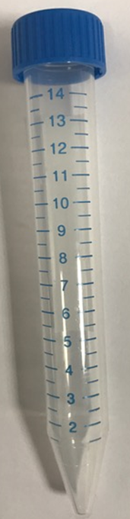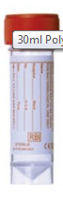 | - Collect the specimen with a sterile syringe.  - Transfer a maximum of 15 ml into a sterile universal container.  - Ensure the cap is tightly screwed on.
Biopsies | Biopsy equipment as appropriate  15 ml or 30 ml sterile universal container (not formalin) |  | - All biopsies should be placed in sterile saline and not in formalin.  - Contact medical virology staff for advice with relevant clinical details  - Please state clearly the clinical diagnosis and the test needed.
Blood  Serum | YELLOW / GOLD topped container  (adult and paediatric shown here) | 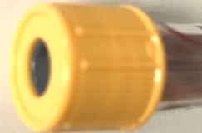  Adult  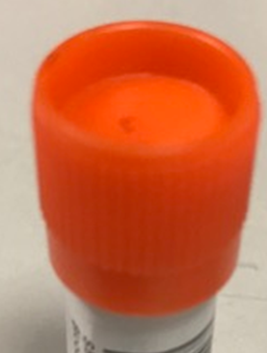  Paediatric | - Collect 10 ml of blood in adults and at least 2 ml in children.  - Serum is used for serological markers for IgG, IgM, total antibody and BBV antigen assays.  - Heparinised blood (green topped) may cause non-specific reactions in some antigen / IgM assay and so is not recommended.
Blood  Whole Blood | Purple / Mauve topped container (EDTA blood)  (adult and paediatric shown here) | 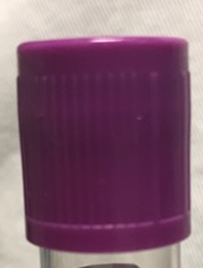  Adult  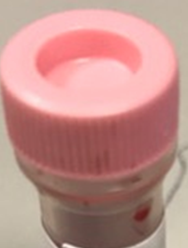  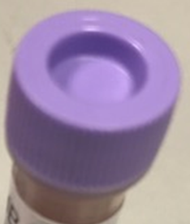  Paediatric | - Collect 10 ml of blood in adults and at least 2 ml in children in one of these blood collection tubes.  - EDTA whole blood is used to assess CMV DNA, EBV DNA, adenovirus DNA, HIV proviral DNA
Blood  Plasma | Purple / Mauve topped container (EDTA blood)  (adult and paediatric shown here) |  | - Collect 10 ml of blood in adults and at least 2 ml in children in one of these blood collection tubes.  - EDTA plasma is used to assess HIV RNA, HBV DNA, HCV RNA, HIV genotypic resistance testing, HHV 6 DNA and HHV 7 DNA testing.

Sample | Material required |  | Methods
Bronchial washings | Bronchial wash equipment (as per the specialist protocols)  15 ml or 30 ml sterile universal container |  | - A specialist will collect the specimen in a sterile container according to local protocol.  - Traps containing a specimen should be sealed by the permanent cap.  - Please do not use the tubing cap itself to seal the tube (because this invariably leaks in transit).
Bronchoalveolar lavage | Bronchial lavage equipment (as per the specialist involved)  15 ml or 30 ml sterile universal container |  | - A specialist will collect the specimen in a sterile container according to local protocol.  - Traps containing a specimen should be sealed by the permanent cap.  - Please do not use the tubing cap itself to seal the tube (because this invariably leaks in transit).
Cerebrospinal fluid (CSF) | Lumbar puncture equipment  15 ml or 30 ml sterile universal container |  | An adequate amount is essential - send at least 2-3ml.
Endocervical swabs for  Chlamydia trachomatis and Neisseria gonorrhoea | APTIMA Unisex Swab for Endocervical and Male Urethral Swab specimens swab  APTIMA swab specimen transport medium.  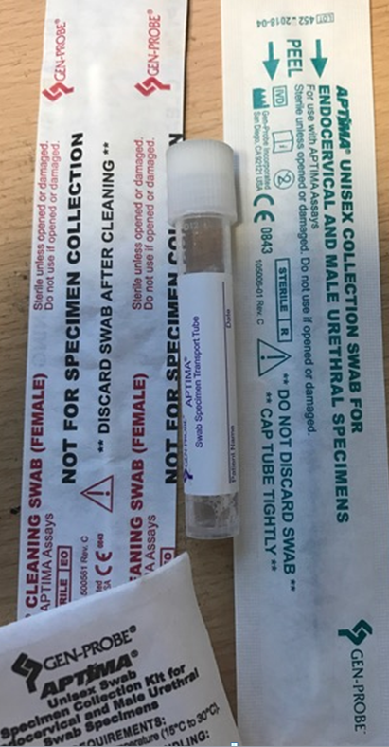 |  | - Remove excess mucus from the Cervical Os and surrounding mucosa using the cleaning swab (white shaft swab in the package with red printing). Discard this swab. Note: To remove excess mucus from the cervical Os, a large-tipped swab may be used.  - Insert the specimen collection swab (blue shaft swab in the package  - Gently rotate the swab clockwise for 10 to 30 seconds in the endocervical canal to ensure adequate sampling.  - Withdraw the swab carefully; avoid any contact with the vaginal mucosa.  - Remove the cap from the swab specimen transport tube and immediately place the specimen collection swab into the transport tube.  - Carefully break the swab shaft against the side of the tube at the score line and discard the top portion of the swab shaft; use care to avoid splashing of contents.  - Re-cap the swab specimen transport tube tightly.
Cervical swabs  for viruses  (not for human papillomaviruses) | Copan FLOQSwab (flocked swabs) in UTM 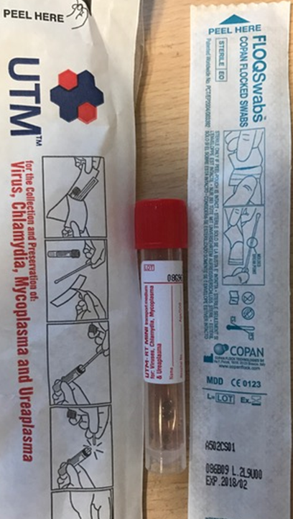 |  | - Moisten the swab in sterile saline before taking the specimen.  - Never moisten swab in VTM.  - Follow procedures as for the Endocervical swab for CT & GC.  - Snap off the swab tip into VTM.

Sample | Material required |  | Methods
Dried Blood Spot (DBS) | BD Microtainer®Contact Activated Lancet  DBS sample collection card (Whatman card) | 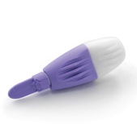 | - After cleansing chosen finger, activate the BD Microtainer®Contact Activated Lancet by pressing it firmly against the puncture site  - Apply the hanging blood drops within an outlined circle of the DBS sample collection card (Whatman card)  - Place the DBS collection card on the drying rack to dry completely before sending it to the laboratory.
Ear swab in VTM (vesicles or part of Bell’s palsy investigation) | Copan FLOQSwab (flocked swabs) in UTM |  | - Place the swab in the ear canal over any vesicle. Rotate gently over the vesicles / ulcers. Place the swab in VTM.
Eye swab for Chlamydia trachomatis: | APTIMA Unisex Swab for Endocervical and Male Urethral Swab specimens swab  APTIMA swab specimen transport medium  - as above for Endovervical swab |  | The aim is to collect epithelial cells and assess Chlamydia trachomatis nucleic acid by TMA.  Scrape from conjunctiva and place the swab in APTIMA sample collection tube, snip off the shaft and screw the cap on.
Eye swab in VTM for viruses: | Copan FLOQSwab (flocked swabs) in UTM |  | Moisten the swab in sterile saline before taking the specimen. Never moisten swab in VTM. Snap off the swab tip into VTM.
Faeces  Rectal swab in VTM | Spatula  15 ml or 30 ml sterile universal container or sterile container with built in spatula  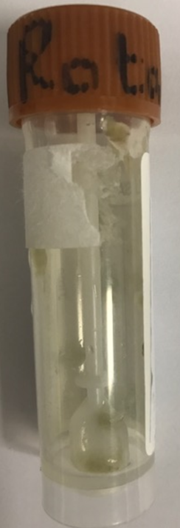 |  | - Send a 2-3 pea-sized portion" or 5-10ml if liquid faeces.  - Ask the patient to defecate into a clean bedpan or other convenient container if at home. Use the plastic spatula to transfer a portion of faeces into the pot. If spatula is part of the lid, insert the spatula and close the lid.  - For liquid faeces use a plastic medicine spoon.  - Rectal swab in VTM is also accepted  - Take care not to contaminate the outside of the faeces pot.

Sample | Material required | Methods
Genital tract swabs for Chlamydia trachomatis and Neisseria gonorrhoae | APTIMA Unisex Swab for Endocervical and Male Urethral Swab specimens swab (these are thin swabs)  APTIMA swab specimen transport medium. | The aim is to collect epithelial cells and assess nucleic acid by APTIMA (TMA).  Scrape from the endothelium and place the swab in APTIMA collection tube, snip off the shaft and screw the cap on
Genital tract swabs in VTM for viruses | Copan FLOQSwab (flocked swabs) in UTM | Moisten the swab in sterile saline before taking the specimen.  Never moisten swab in VTM.  Snap off the swab tip into VTM.
High vaginal swabs for Chlamydia trachomatis and Neisseria gonorrhoae | APTIMA Multi-test swab and APTIMA swab specimen transport medium.  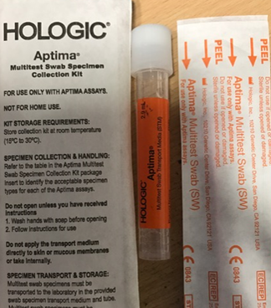 | Introduce the speculum. Roll the swab firmly over the surface of the vaginal vault.  Place the swab in APTIMA swab specimen transport medium.
High vaginal swabs in VTM for viruses | Copan FLOQSwab (flocked swabs) in UTM | Introduce the speculum.  Roll the swab firmly over the surface of the vaginal vault.  Place the swab in VTM.

Sample | Material required | Methods
Mouth swabs in VTM | Copan FLOQSwab (flocked swabs) in UTM | For HSV, enterovirus and VZV within any vesicle lesions or ulcers or inflamed areas – swab the ulcer or vesicle  For measles, mumps and rubella – ensure the swab is soaked in saliva [see saliva in VTM below]  A tongue depressor or spatula may be helpful to aid vision and avoid contamination from other parts of the mouth.  Place the swab in the VTM.
Respiratory  Nasopharyngeal Swab (NPS)  A NPS is the optimal upper respiratory tract specimen collection method. However, such specimens cannot be collected from infants and many older patients may not allow an NP specimen to be collected. | Copan FLOQSwab (flocked swabs) in UTM  Virus PCR Sample Solution (VPSS) | - Tilt patient’s head back 70 degrees.  - Insert swab into nostril  - Swab should reach depth equal to distance from nostrils to outer opening of the ear.  - Leave swab in place for several seconds to absorb secretions.  - Slowly remove swab while rotating it. (Swab both nostrils with same swab.)  - Place tip of swab into sterile viral transport media tube and snap/cut off the applicator stick.
Respiratory Nasopharyngeal Aspirate (NPA) or Nasal Aspirate  Note: NPA may not be possible to conduct in infants | Suction pump, sterile suction catheter (usually size 10, smaller for infants)  15 ml or 30 ml sterile universal container  Traps containing a specimen should be sealed using a loop of tubing | - Attach catheter to suction apparatus.  - Tilt patient’s head back 70 degrees.  - Insert catheter into nostril. Catheter should reach depth equal to distance from nostrils to outer opening of ear. Stop when you feel a resistance (you have reached the posterior nasopharynx).  - Begin gentle suction.  - Catheter should remain in nasopharynx no longer than 10 seconds. Remove catheter while rotating it gently.  - Traps containing a specimen should be sealed by the permanent cap. Please do not use the tubing cap itself to seal the tube (because this invariably leaks in transit).  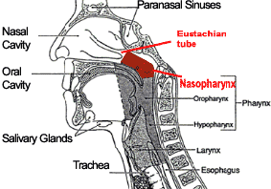

Sample | Material required | Methods
Respiratory  Nasopharyngeal Wash or  Nasal Wash  Note: NP wash may not be possible to conduct in infants | Sterile suction catheter/suction apparatus  Sterile normal saline  15 ml or 30 ml sterile universal container | - Attach catheter to suction apparatus.  - Tilt patient’s head back 70 degrees.  - Insert several drops of sterile normal saline into each nostril.  - Insert catheter into nostril. (Catheter should reach depth equal to distance from nostrils to outer opening of ear.)  - Begin gentle suction.  - Remove catheter while rotating it gently.  - Place catheter in sterile viral transport media tube or sterile universal container.
Respiratory  Deep Nasal Swab in VTM | Sterile polyester swab (aluminium or plastic shaft preferred) or Copan FLOQSwab (flocked swabs) in UTM  Virus PCR Sample Solution (VPSS) | - Tilt patient’s head back 70 degrees.  - While gently rotating the swab, insert swab less than one inch into nostril (until resistance is met at turbinates).  - Rotate the swab several times against nasal wall and repeat in other nostril using the same swab.  - Place tip of the swab into sterile viral transport media tube and cut off the applicator stick.
Respiratory Combined Nasal & Throat Swab in VTM  This is the preferred respiratory sampling in URTI | Copan FLOQSwab (flocked swabs) in UTM  Virus PCR Sample Solution (VPSS) | Nasals swab:  - Tilt patient’s head back 70 degrees.  - Take a dry swab, insert into mouth, and swab the posterior pharynx and tonsillar areas (avoid the tongue).  - Use the same swab and insert it less than one inch into nostril (anterior nares) until resistance is met at turbinates  - Rotate the swab several times against nasal wall and repeat in other nostril using the same swab.  - Place tip of the swab into sterile viral transport media tube and cut off the applicator stick.
VirNA Combined Nasal & Throat Swab for SARS CoV-2 RNA testing | 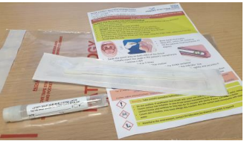 | Full sampling and labelling instruction provided in the leaflet provided with the kit

Sample | Material required |  | Methods
Saliva in VTM  (for measles, mumps and rubella virus RNA)  Saliva in Oracol (for measles, mumps and rubella virus RNA) | Copan FLOQSwab (flocked swabs) in UTM |  | - The saliva specimen is obtained by rubbing the swab on the inside of the mouth like a tooth brush until the swab is saturated with saliva.  - It takes 1 to 2 minutes for the swab to be saturated.  - The swab is then inserted in to the red tube provided.
 | If available,  Malvern Oracol saliva testing kit  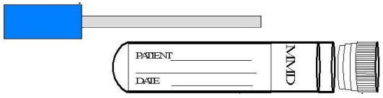 |  | - The saliva specimen is obtained by rubbing the sponge which is on a stick (Oracol Saliva Collection System; Malvern Medical Developments Limited) on the inside of the mouth like a tooth brush until the sponge is saturated with saliva.  - It takes 1 to 2 minutes for the sponge to be saturated.  - The sponge is then inserted in to the plastic tube provided.
Serum | YELLOW / GOLD topped container | Adult  Paediatric | Collect 10 ml of blood in adults and at least 2 ml in children.  Serum is used for serological markers for IgG, IgM, total antibody and some BBV antigen assays.  Heparinised blood (green topped) may cause non-specific reactions in some antigen / IgM assay and so is not recommended.
Sputum | 15 ml or 30 ml sterile universal container |  | - Ask a physiotherapist to assist if a patient has difficulty in producing satisfactory specimens.  - Induced sputum or expectorated sputum can be used for virological assessment.  - Do not collect shortly after the patient has been eating, drinking or cleaning their teeth.  - It is usually difficult to perform respiratory PCRs on this sample.
Surface swabs and skin swabs | Copan FLOQSwab (flocked swabs) in UTM |  | Swab the area of concern vigorously. Send swab in VTM Rotate the swab on or in the required site. Place the swab in the VTM.
Tissues and biopsies | Sterile saline.  15 ml or 30 ml sterile universal container |  | Under aseptic conditions transfer material to a sterile universal container that does not contain formalin as this inactivates pathogens very rapidly.  Send in 0.5ml of sterile saline. Please specify which virus is being investigated for virology.
Sample | Material required |  | Methods
Urethral swabs Chlamydia trachomatis and Neisseria gonorrhoea: | APTIMA Unisex Swab for Endocervical and Male Urethral Swab specimens swab  APTIMA swab specimen transport medium. |  | - Male urethral swab  - The patient should not have urinated for at least 1 hour prior to sample collection.  - Insert the specimen collection swab (blue shaft swab in the package with the green printing) 2 to 4 cm into the urethra.  - Gently rotate the swab clockwise for 2 to 3 seconds in the urethra to ensure adequate sampling. 4. Withdraw the swab carefully.  - Remove the cap from the swab specimen transport tube and immediately place the specimen collection swab into the transport tube.  - Carefully break the swab shaft against the side of the tube at the score line and discard the top portion of the swab shaft; use care to avoid splashing of contents.  - Re-cap the swab specimen transport tube tightly.
Urine  Clean-voided midstream urine is preferred for virology. | 15 ml or 30 ml sterile universal container |  | - It is recommended that in females the hands and the perineal area should be washed with soap and water prior to specimen collection. Part the labia and clean the area around the urethral meatus from front to back. Spread the labia with the fingers of one hand.  - In males retract the foreskin, if present, and clean the skin surrounding the urethral meatus.  - Start passing urine into the toilet, bedpan or urinal. When the urine is flowing freely, collect urine in a clean sterile container.  - Special urine collection pouches are needed for collection in paediatric patients.
First catch urine for Chlamydia trachomatis and Neisseria gonorrhoea  (not for female Neisseria gonorrhoea testing) | APTIMA Urine Specimen Collection Kit 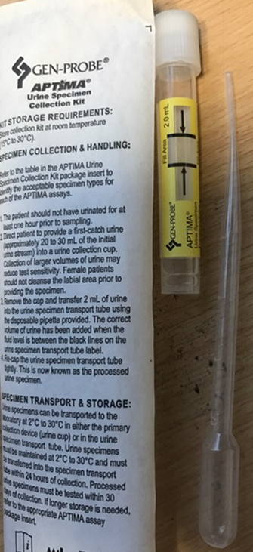 |  | - The patient should not have urinated for at least 1 hour prior to specimen collection.  - Direct patient to provide a first-catch urine (approximately 20 to 30 mL of the initial urine stream) into a urine collection cup free of any preservatives. Collection of larger volumes of urine may result in rRNA target dilution that may reduce test sensitivity. Female patients should not cleanse the labial area prior to providing the specimen.  - Remove the cap and transfer 2 mL of urine into the urine specimen transport tube using the disposable pipette provided. The correct volume of urine has been added when the fluid level is between the black fill lines on the urine specimen transport tube label.  - Re-cap the urine specimen transport tube tightly.

Sample | Material required | Methods
Vesicles, ulcers and genital lesions in VTM | Copan FLOQSwab (flocked swabs) in UTM | - Method  - Burst a vesicle using a sterile needle and collect with a swab or aspirate the fluid contents of the vesicle.  - Alternatively, scrape the base of the vesicle or ulcer with a swab so that cellular material is collected. Inoculate this fluid / cellular material into VTM.  - Always state the site, distribution and nature of the vesicle. This is essential, as the laboratory may need to prioritise between HSV / VZV and enterovirus testing.

External Quality Assurance (EQA) scheme participation

Process / Test | EQA Schemes
Adenovirus DNA quantitative | QCMD
Arbovirus serology and molecular | Referred sample
Antistreptolysin-O titre (ASO) | NEQAS & LABQUALITY
Avian influenza A virus H5N1 | Referred sample
BK virus DNA | QCMD
CFT for Chlamydia genus, M. pneumoniae, C. burnetii | LABQUALITY
Chlamydia trachomatis NAAT/ Neisseria gonorrhoea DNA | NEQAS
Cytomegalovirus DNA | QCMD
Cytomegalovirus IgG | NEQAS
Cytomegalovirus IgG avidity | NEQAS
Cytomegalovirus IgM | NEQAS
Cytomegalovirus resistance testing | Referred sample
Dried Blood Spot (DBS) tests for HIV antibody, HBsAg, HB core total antibody, HCV antibody and HCV RNA | No external scheme available
Epstein Barr virus DNA | QCMD & NEQAS
Epstein Barr virus VCA IgG | NEQAS
Epstein Barr virus VCA IgM  Epstein Barr virus VCA IgG (Avidity) | NEQAS  Sample Exchange with GSTT
Electron microscopy | Referred sample
Enterovirus antibody (IgM and neutralisation) | Referred sample
Enterovirus RNA | QCMD
HB core IgM | NEQAS
HB core total antibody | NEQAS
HBeAg | NEQAS
HBeAg | NEQAS
HBV DNA | QCMD
HBV e antibody | NEQAS
Hepatitis B surface antibody level | NEQAS
HBV resistance testing | QCMD
HDV antibody (IgG and IgM) | Referred sample
Hepatitis A virus IgM | NEQAS
Hepatitis A virus RNA | Referred sample

Process / Test | EQA Schemes
Hepatitis A virus total | NEQAS
Hepatitis C virus antibody | NEQAS
Hepatitis C virus RNA | QCMD
HEV antibody (IgG and IgM) | NEQAS
HEV RNA | QCMD
HHV 6 DNA | QCMD
HHV 7 DNA | QCMD
HHV 8 DNA | Referred sample
HIV antibody | NEQAS
HIV immunoblot (HIV Line Immunoblot Assay) | NEQAS
HIV-1 p24 antigen | NEQAS
HIV-1 genotypic resistance testing RT, Protease and Integrase | QCMD & UK HSA Colindale panel
HIV-2 genotypic resistance testing | Referred sample
HIV-1 RNA | VQA and NEQAS
HIV-2 viral load | Referred sample
HIV-1 proviral DNA | Referred sample
HIV-1 phenotypic resistance testing | Referred sample
HIV-1 CCR5 Tropism assay | QCMD & UK HSA Colindale panel
HIV-2 integrase inhibitor resistance assay | Referred sample
HSV 1 and 2 DNA | QCMD
HSV IgG | LABQUALITY
HSV IgG type specific serology | Referred sample
HTLV antibody | NEQAS
HTLV proviral DNA | Referred sample
HTLV immunoblot | Referred sample
Influenza A virus RNA (see Respiratory virus RNA / DNA below) | See below
JC virus DNA | QCMD
JC virus HI | Referred sample
Measles IgG | NEQAS
Measles IgM | Referred sample
Measles RNA | Referred sample
Microbiology Send Always (like Lyme serology, schistosomiasis etc.) | Referred sample
Mumps IgG | NEQAS
Mumps IgM | Referred sample
Mumps RNA | Referred sample
Viral Gastroenteritis | QCMD
Parvovirus B19 DNA | Referred sample
Parvovirus B19 IgG | NEQAS & LABQUALITY
Parvovirus B19 IgM | NEQAS &LABQAULITY
Respiratory viral RNA / DNA  RNA for influenza A virus, influenza B virus, parainfluenza 1, 2 & 3, rhinovirus, human metapneumovirus, RSV A and RSV B.  DNA for adenovirus | QCMD & NEQAS  UK HSA Colindale panel

Process / Test | EQA Schemes
SARS-CoV-2 RNA | QCMD and NEQAS
Rheumatoid Factor (RF) | NEQAS
Rotavirus RNA | QCMD
Rubella virus IgG | NEQAS
Rubella virus IgG avidity | Referred sample
Rubella virus IgM | NEQAS
Rubella virus RNA | Referred sample
Toxoplasma dye test | Referred sample
Toxoplasma IgG | NEQAS
Treponemal antibody | NEQAS
Treponemal IgM | NEQAS
Treponemal RPR | NEQAS
Virus isolation | QCMD & NEQAS
Varicella zoster virus DNA | QCMD
Varicella zoster virus IgG | NEQAS

